Receipt pro Shortcuts

**Row Movements**

Row Up - Shift + Up Arrow

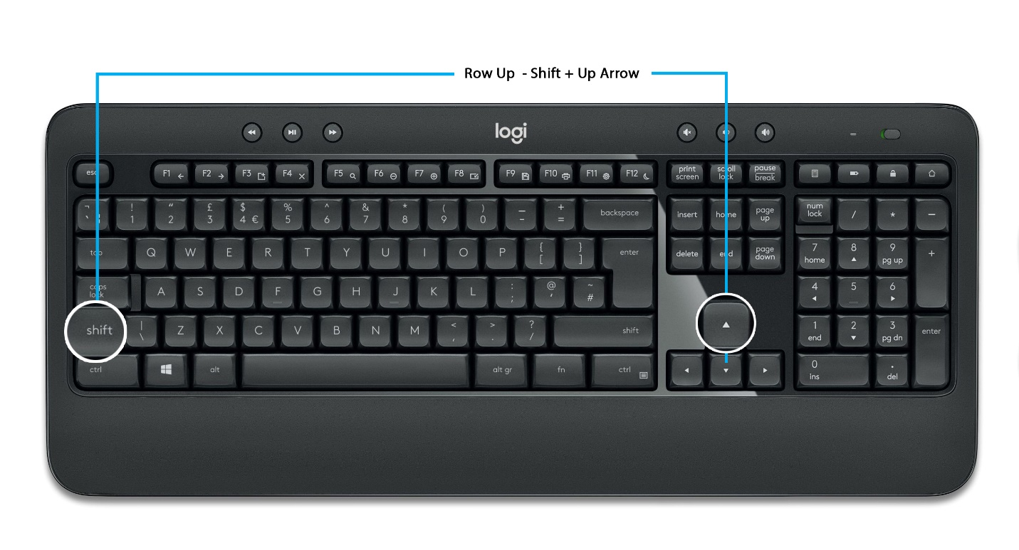

Row Down - Shift + Down Arrow

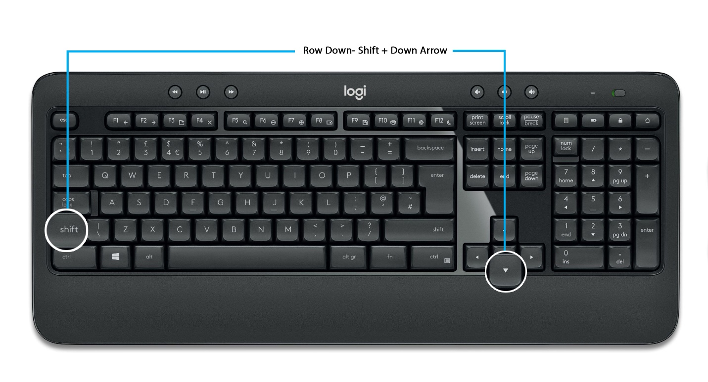

Row Left - Shift + Left Arrow

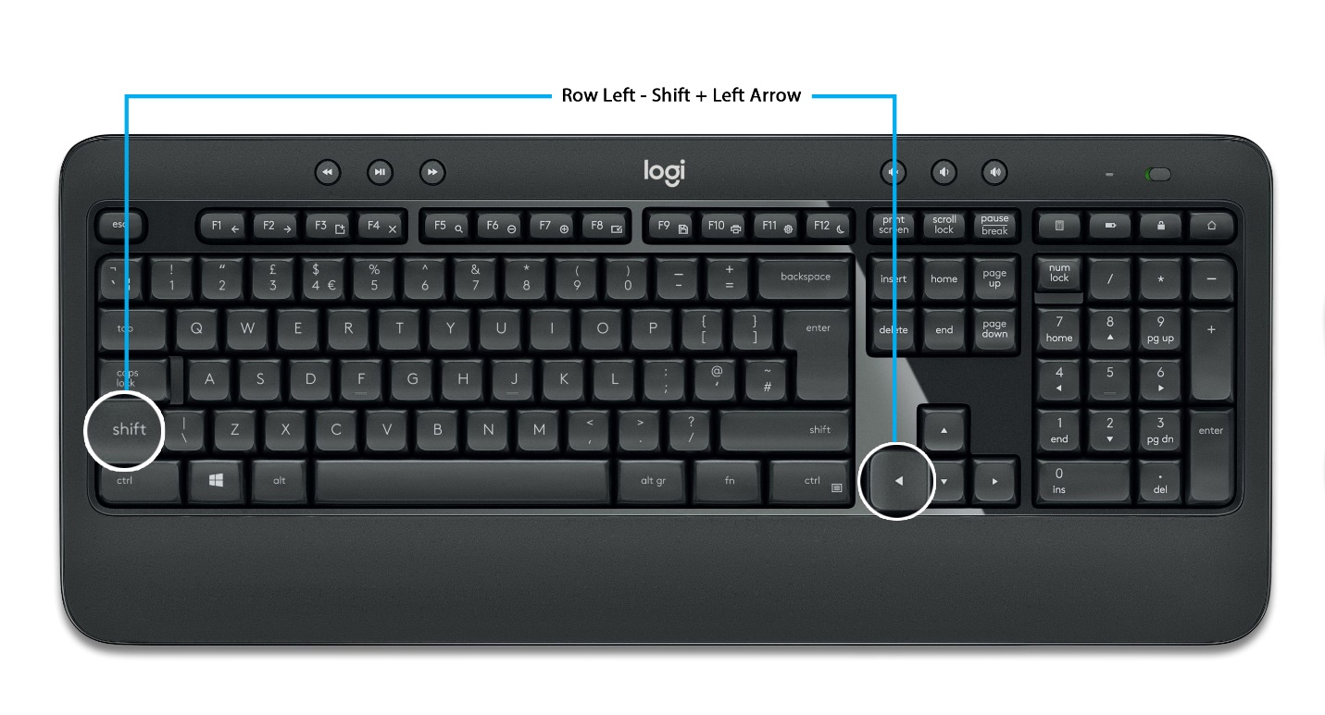

Row Right - Shift + Right Arrow

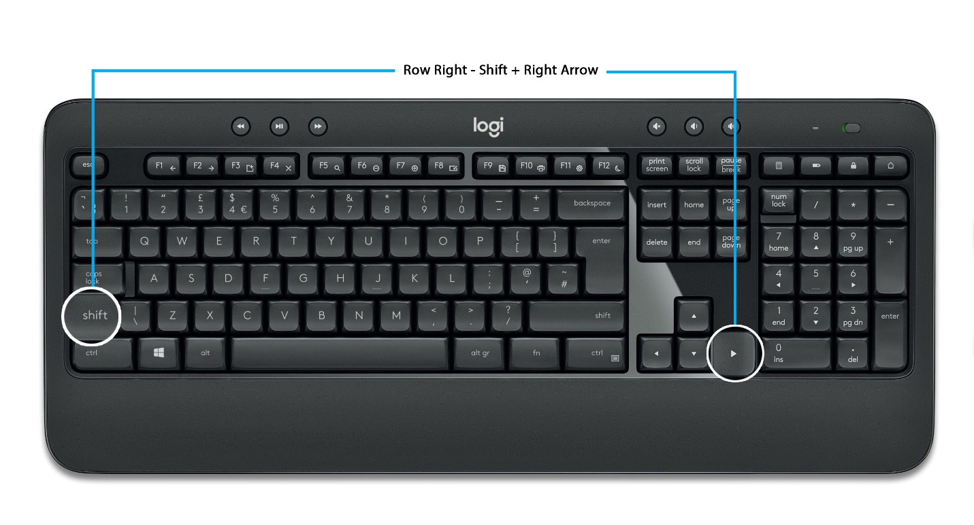

Create new Row - Alt + N

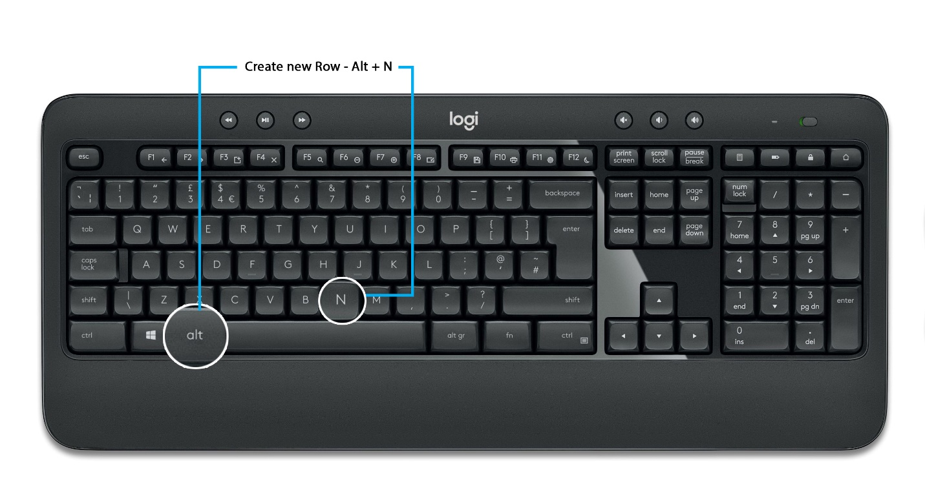

Delete a row - Alt + Z

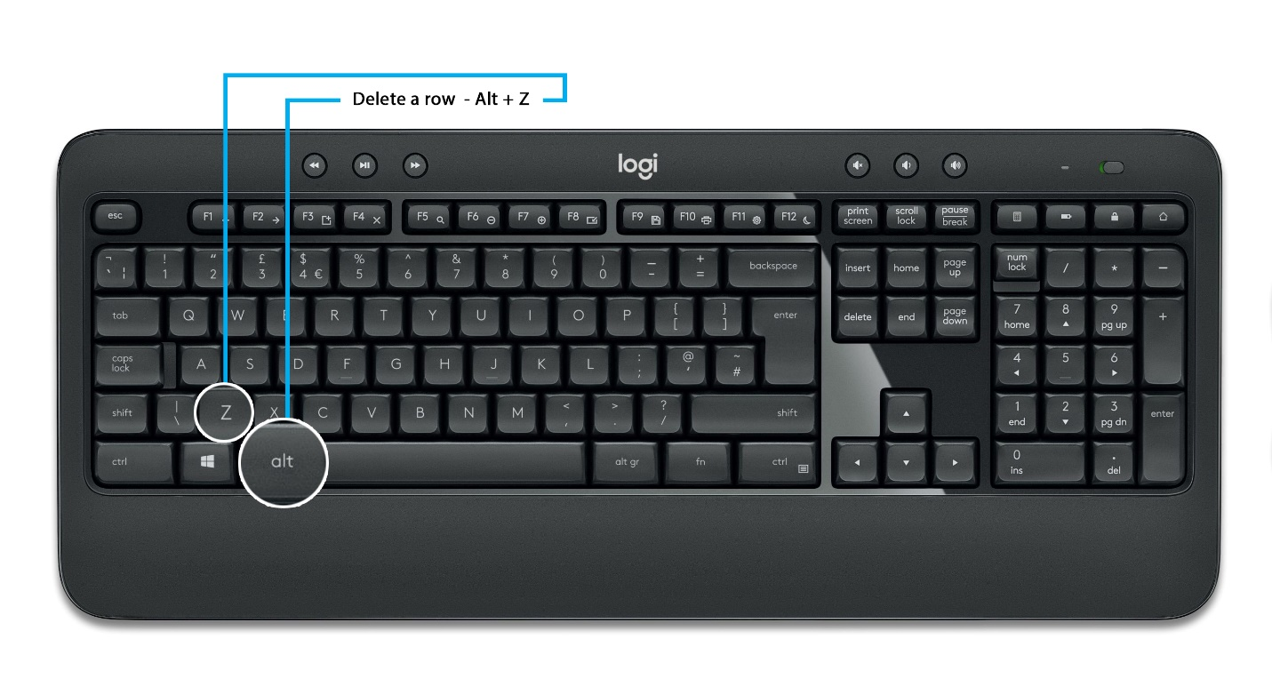

Copy a Row - Ctrl + C

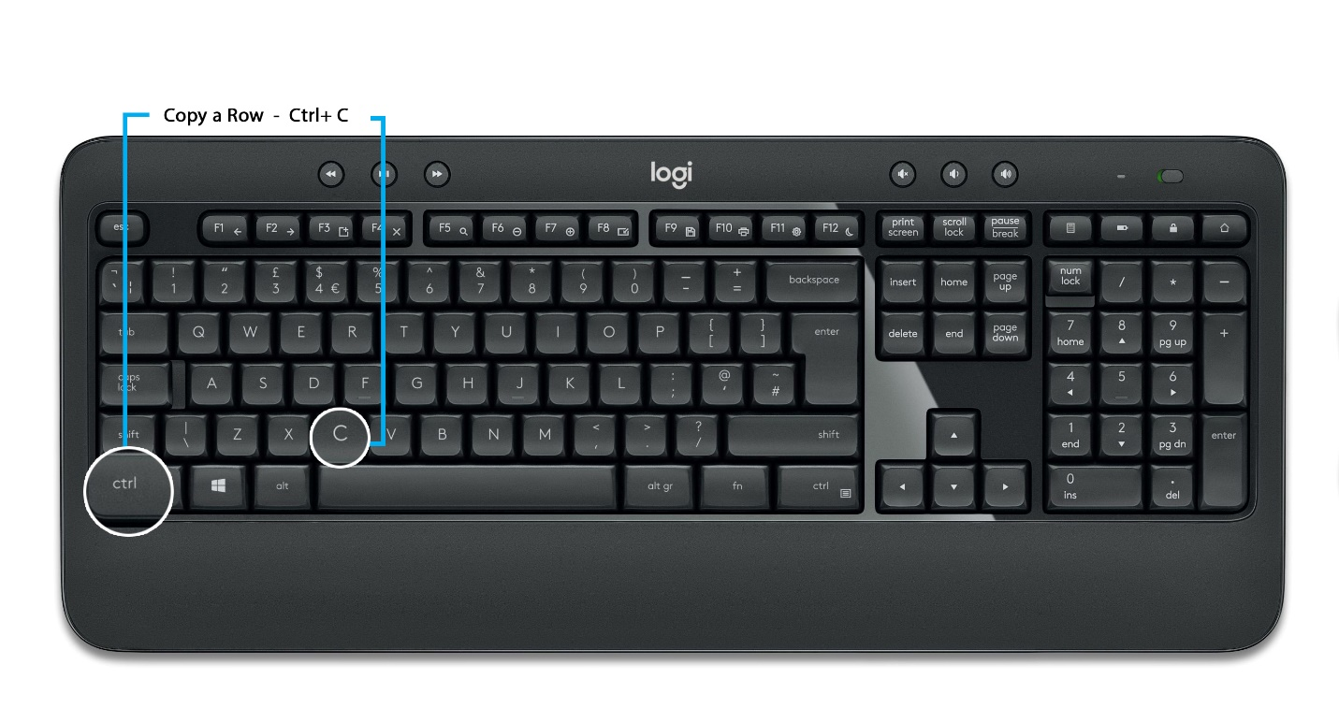

Focus on New Line - Enter (Also Create a new row.)

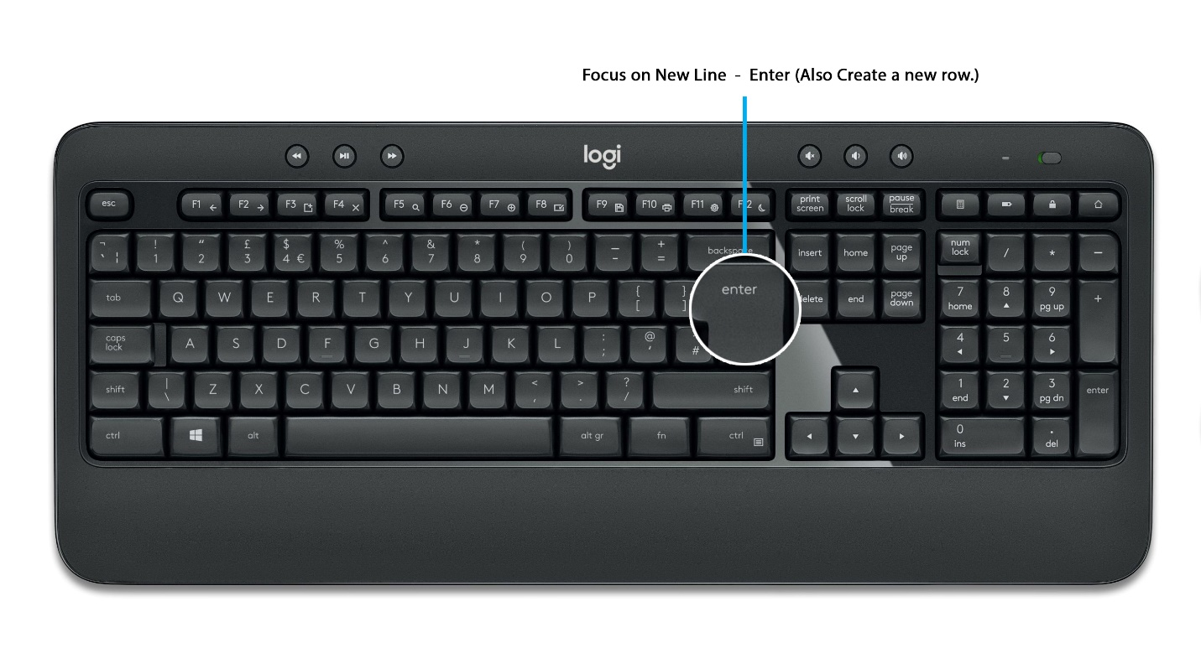

**Image Movements**

Next image - Ctrl + Right Arrow

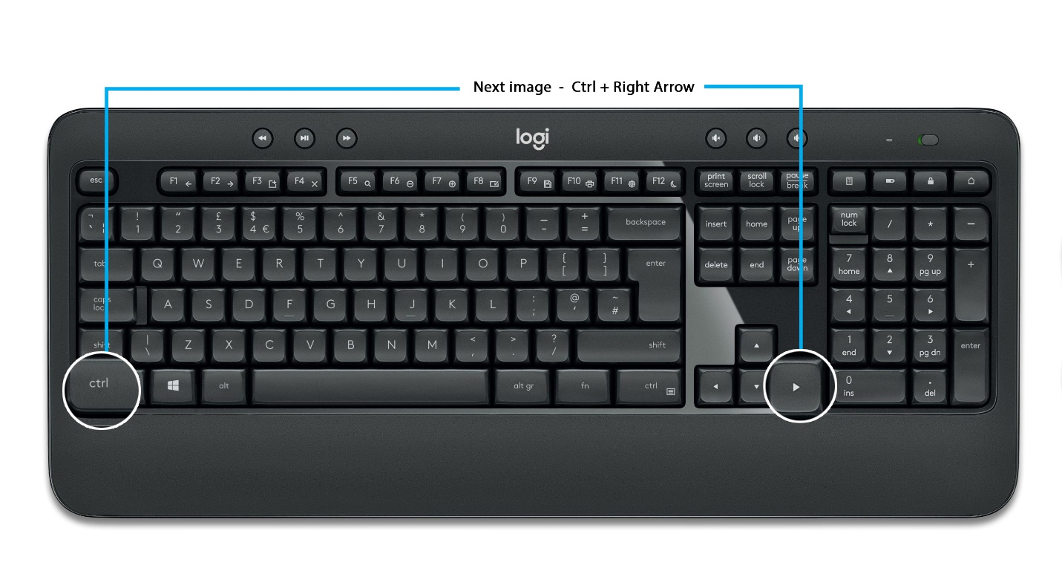

Previous Image - Ctrl + Left Arrow

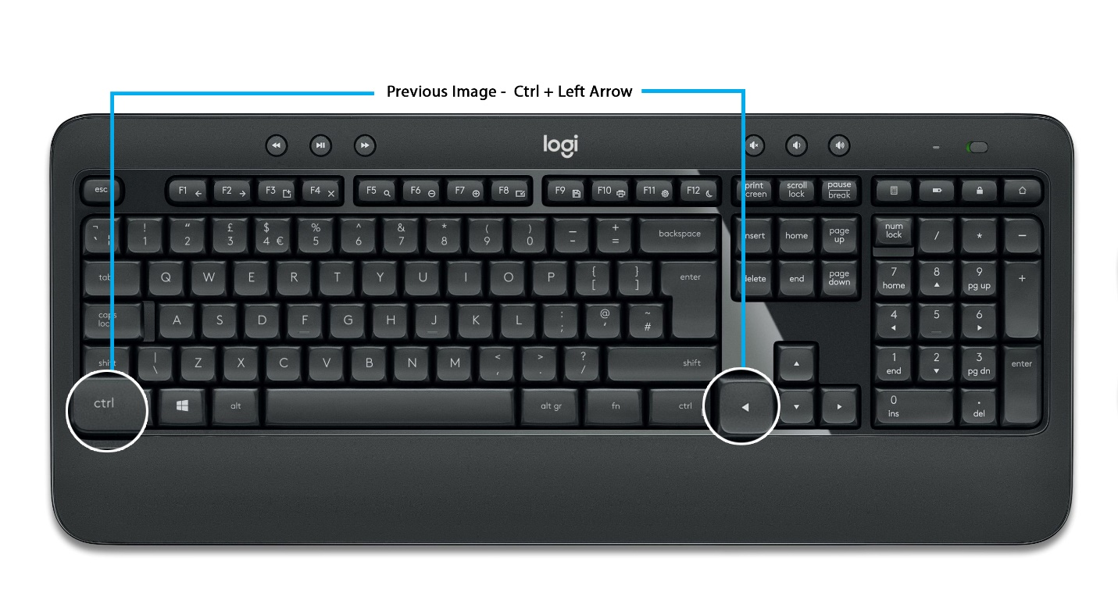

Image Zoomin - - Shift + “+” button on Numpad

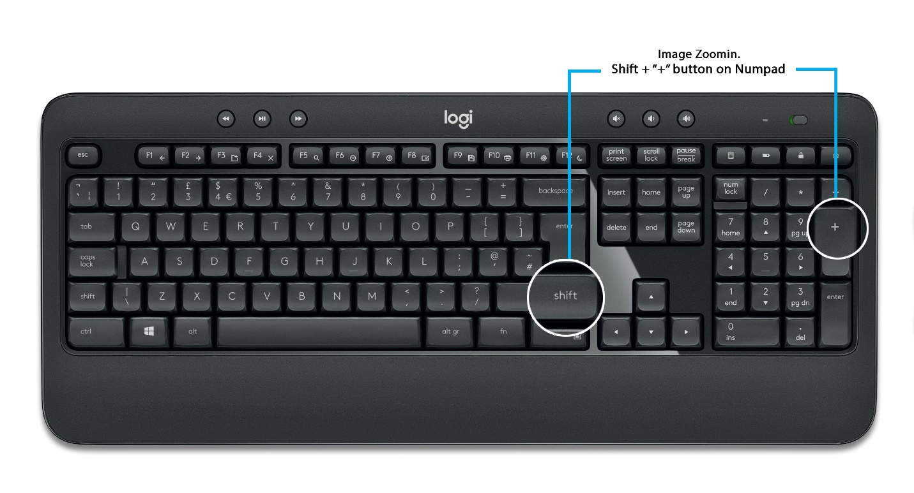

Image Zoomout - - Shift + “-” button on Numpad

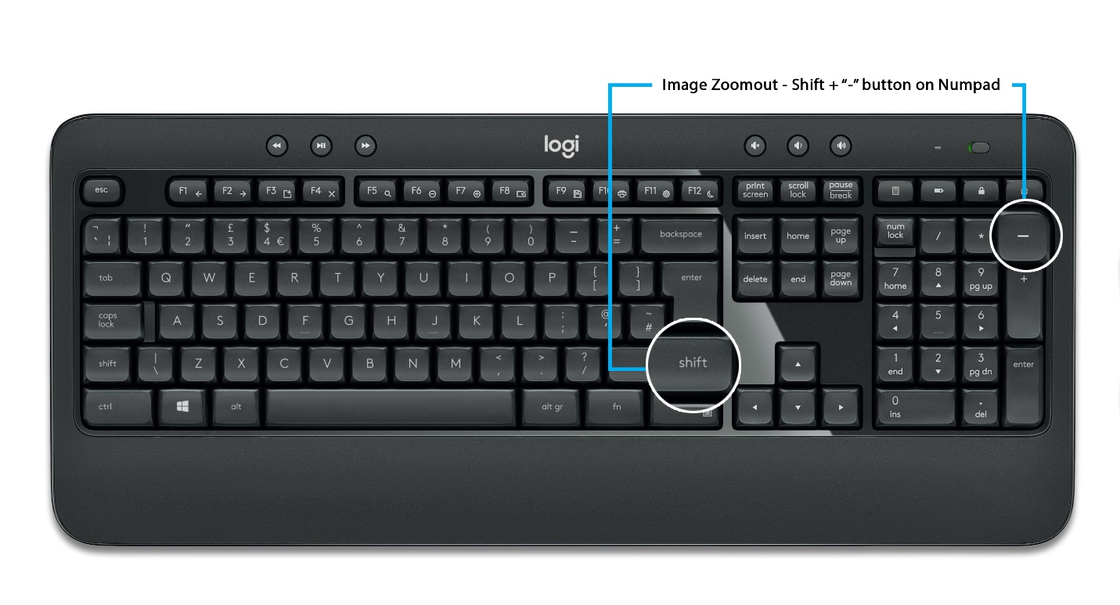

Image small zoomin - “+” button on Numpad

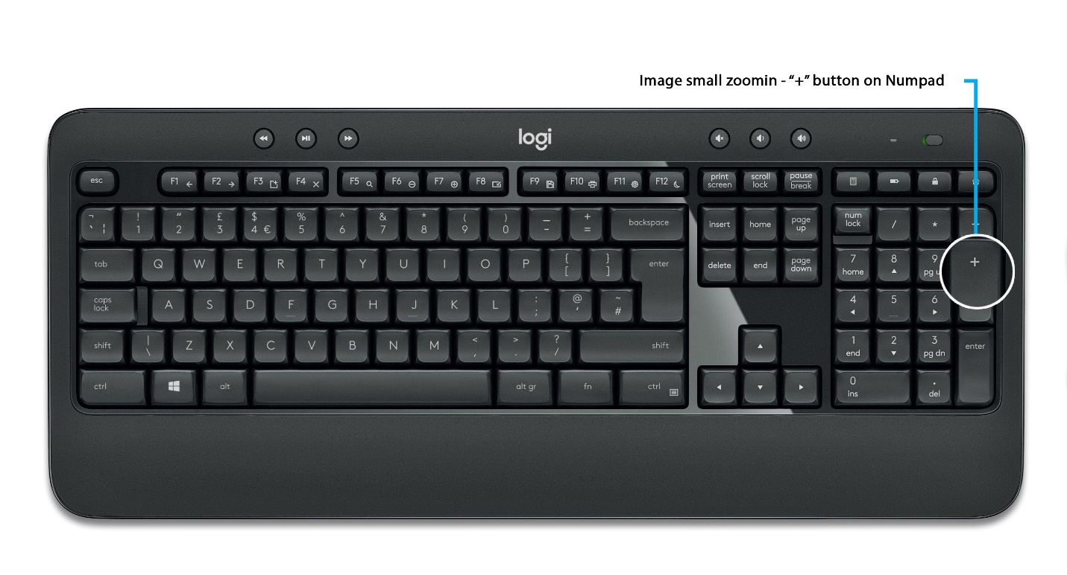

Image small zoomout - “-” button on Numpad

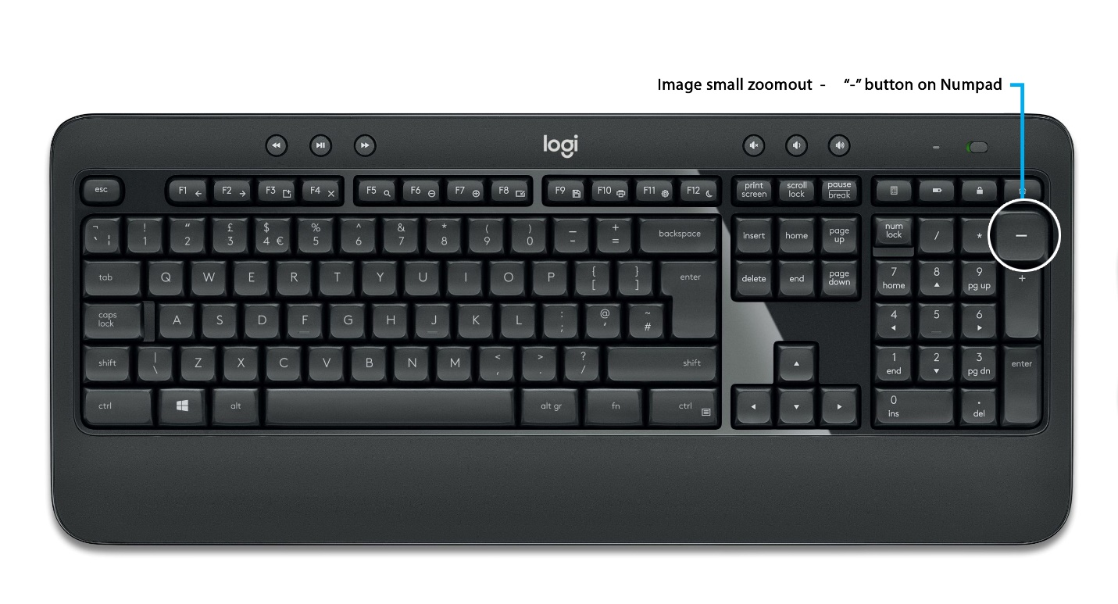

Image Movements - - Left side – left Arrow

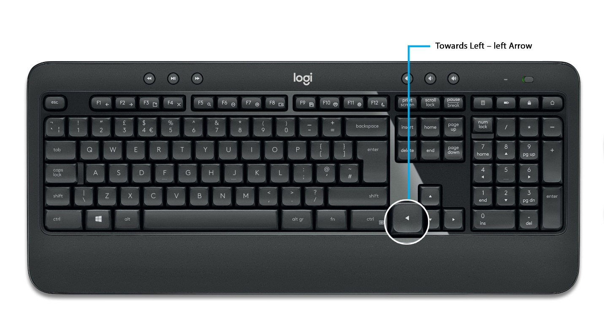

- Right Side – Right Arrow

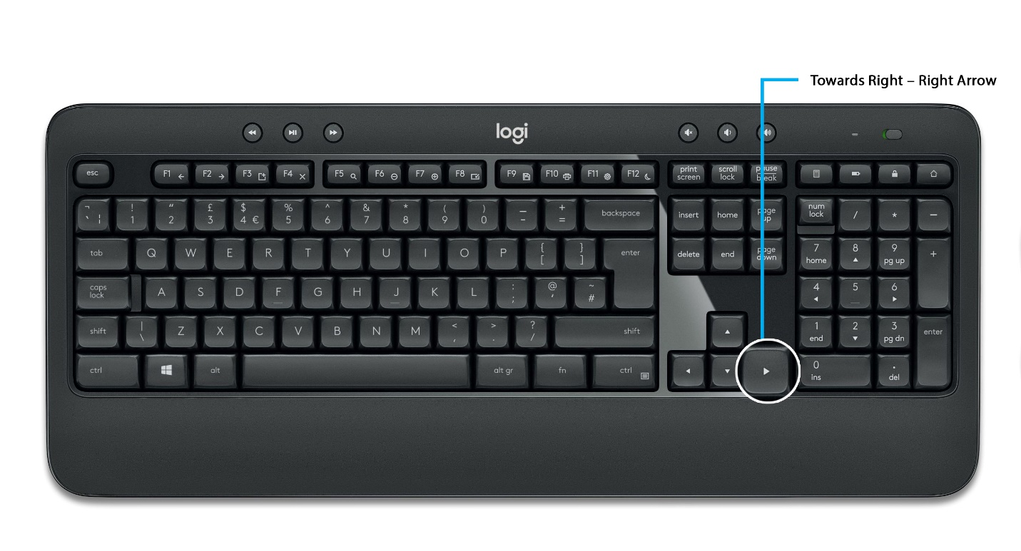

- Top side – Top Arrow

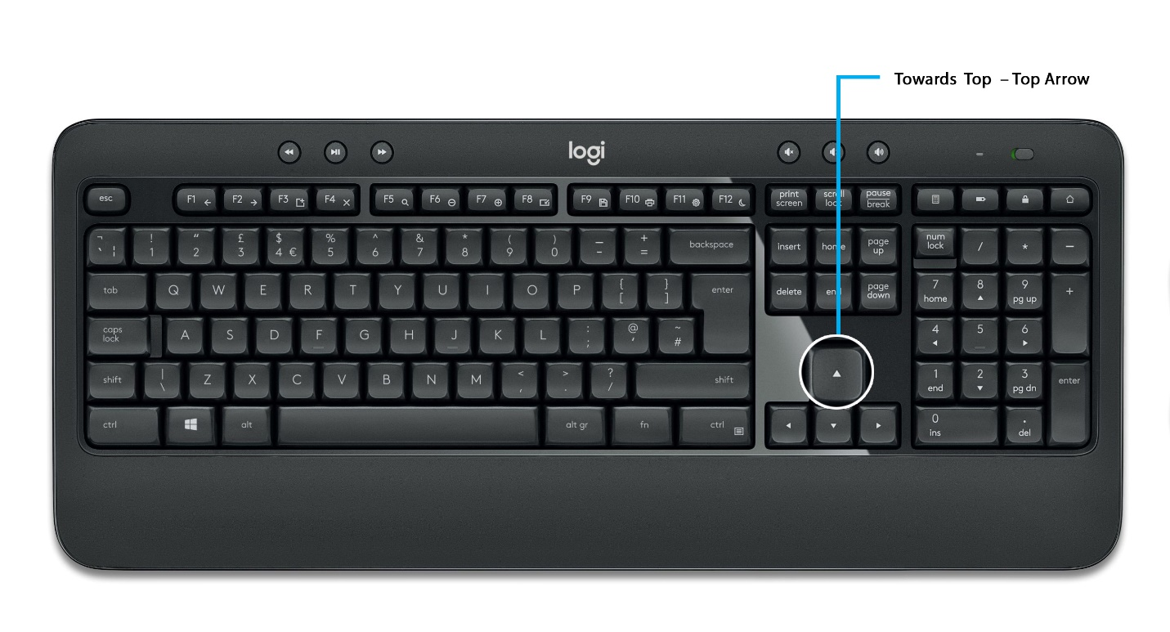

- Bottom – Down Arrow



Back to input area after Zoom - Shift + “Space Bar”

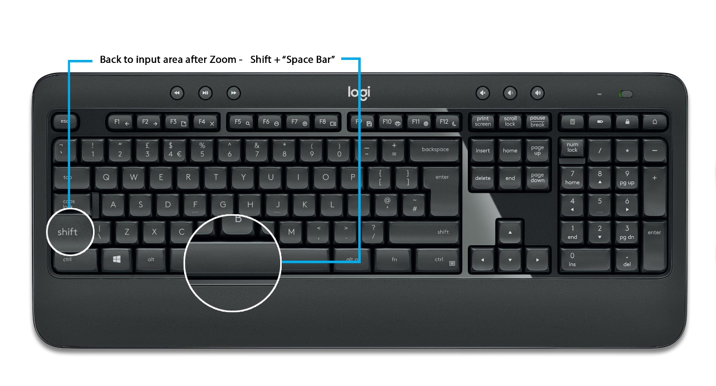

**Change Pages**

Forward Movement - Ctrl + “>”

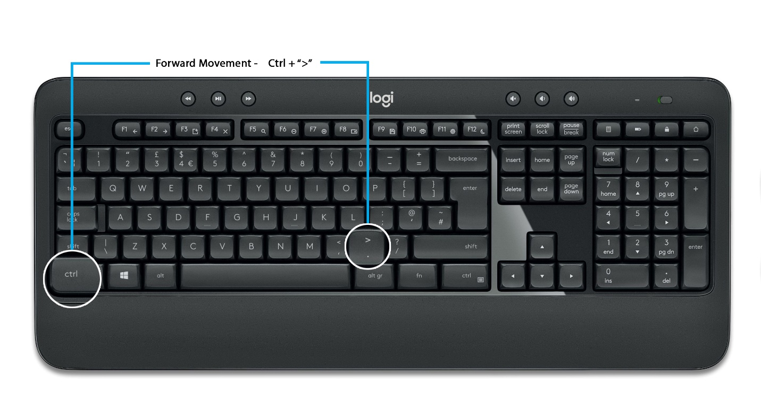

Backward Movement- Ctrl + “<”

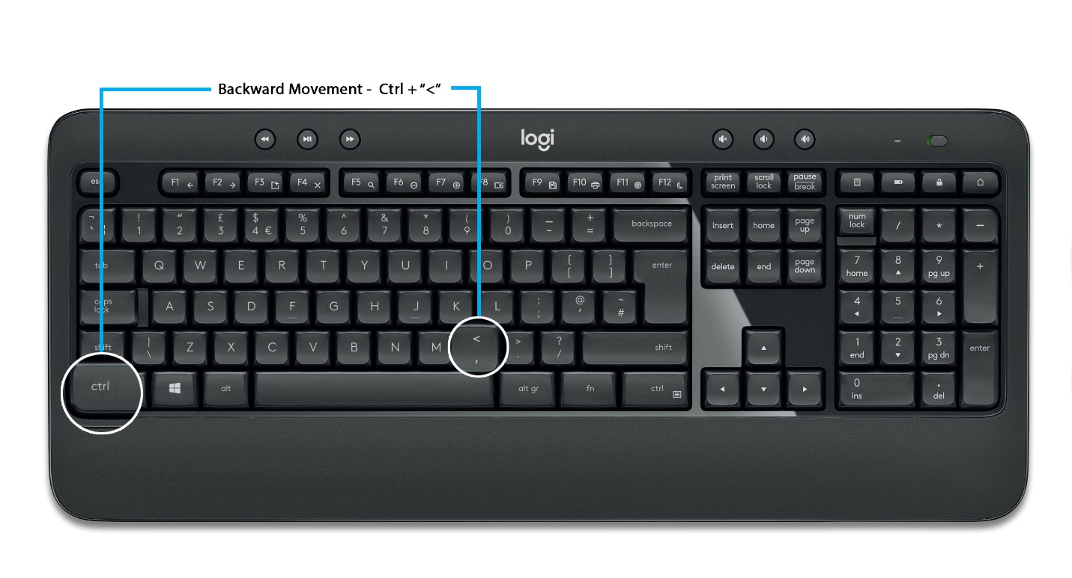

Change Readable form to Not Readable - Ctrl + “Up Arrow”

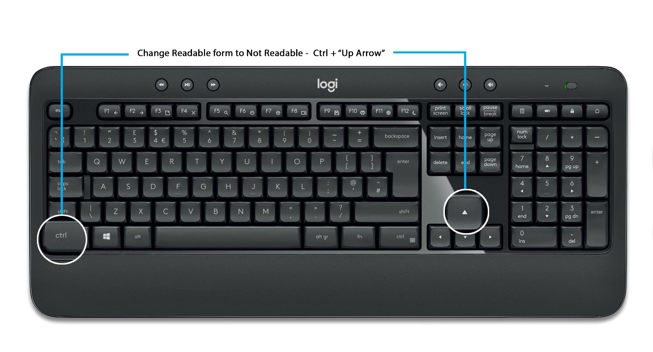

Change Non Readable form to Readable - Ctrl + “Down Arrow”

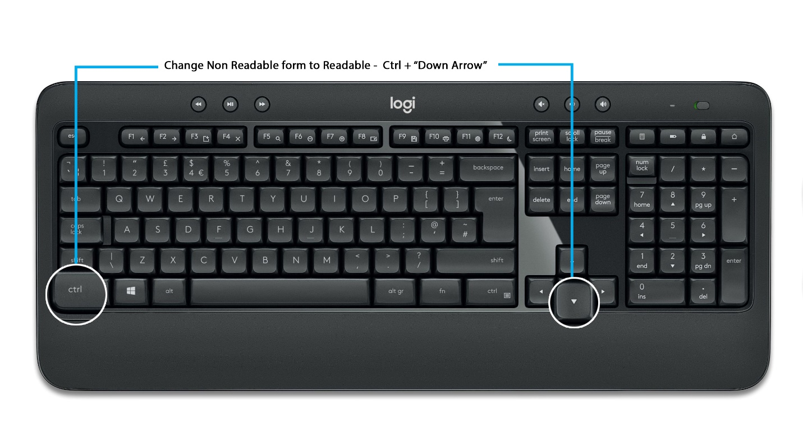

Change Cursor from Top to Bottom - Shift + “End” Key

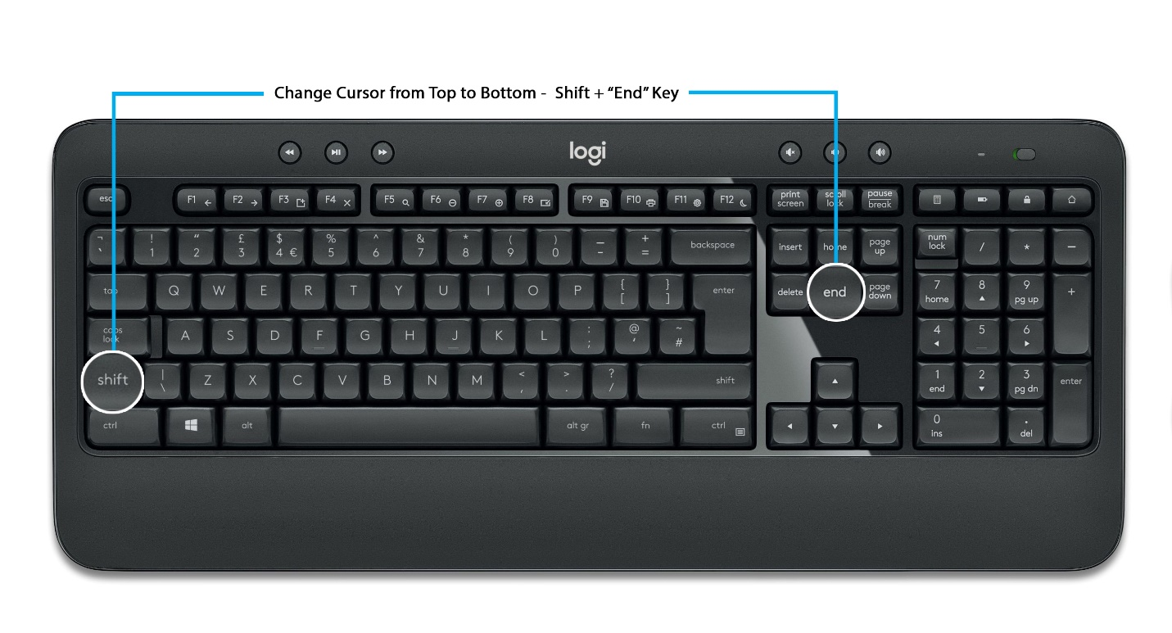

Change Cursor from Bottom to Top – Shift + “Home” Key

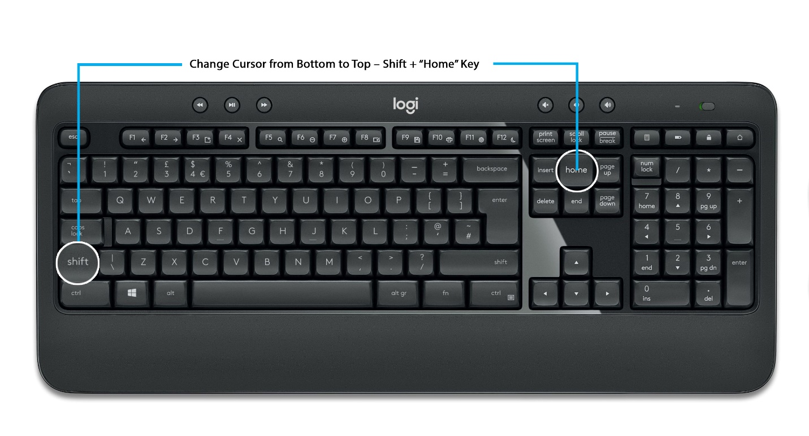

Submit a form - - F9

